 | SIMATS ENGINEERING  Department of Computer Science and Engineering
CSA15 Cloud Computing and Big Data Analytics
CO4 AT3 - Big Data Reverse Engineering Task Workbook
Course Code | CSA15 | Slot | B
Assessment | CO4 AT3 | Bloom Level | BL4 - Analyze
Faculty | Dr C. Rajesh Babu | Employee ID | SSETSCS415
Mode | Individual guided reverse-engineering workbook | Submission | GitHub repository link through Google Classroom
End Evidence | Workbook + screenshots + diagrams + presentation | Marks | 30

Student Details
Student Name | M Deepika | Register Number | 192311027
Class / Section | BE CSE | Slot | B
Selected Platform | Amazon – E-Commerce Platform | Submission Date
GitHub Link |  | Google Classroom Status
Workbook Purpose
What this workbook does
This workbook guides students to reverse-engineer a real, known digital platform purely from observable behaviour — no source code or internal documentation — and infer its likely data pipeline, analytics approach, privacy/security risks and the business decisions that analytics probably drives.

• Do not claim access to private source code or internal documentation you do not actually have.
• Base every inference on observable evidence: app/website behaviour, published engineering blogs, app store listings, public API docs, news articles, the privacy policy.
• Screenshots and cited sources are evidence; your reasoning is the actual assessment answer.
• Being explicit about what you are confident about versus what you are guessing is part of the grade, not a weakness.

Platform Bank
Instruction
Faculty may assign one platform or allow student choice. If self-selecting, pick a platform you personally use and can observe closely (create test interactions, check settings and notifications, read the privacy policy) rather than one you only know by reputation.

No. | Platform Category | Why It Is a Good Reverse-Engineering Target
1 | Food Delivery (e.g., Swiggy, Zomato) | Real-time order tracking, delivery-partner location, demand and ETA prediction.
2 | Streaming (e.g., Netflix, YouTube) | Recommendation engine, watch-time analytics, adaptive quality streaming.
3 | Ride-Hailing (e.g., Ola, Uber) | Real-time GPS matching, surge pricing, ETA prediction.
4 | E-Commerce (e.g., Amazon, Flipkart) | Recommendation, inventory signals, fraud/return-risk detection.
5 | Social Media (e.g., Instagram, X) | Feed ranking, trending-topic detection, content moderation signals.

Selected Platform and Reason
I selected Amazon because it is one of the widely used e-commerce platforms.
It handles a large amount of data from users, products, orders, and reviews.
It provides features such as product search, recommendations, shopping cart, and order tracking.
These features help in understanding how big data is generated and processed in real time.
It is also useful for studying cloud architecture, data processing, scalability, and security.
Therefore, Amazon is suitable for this Big Data Reverse Engineering task.

Guided Tool Module 1: Observe the Platform Directly (Behavioural Reconnaissance)
Purpose: Collect observable evidence of how the platform actually behaves under normal and edge-case use, before inferring any internal architecture. Follow every sub-step below in order.
Step 1.1: Open the Platform and Sign In
• Mobile app: open the Play Store (Android) or App Store (iPhone), search the exact platform name, tap Install if not already installed, then open it.
• Website: open any browser, type the exact web address, and press Enter.
• Log in, or create a free test account if you don't already have one. Never enter real payment card details for this exercise.

Student Note
Take one screenshot of the home/landing screen right now. This is your first evidence item — label it "01_home_screen".
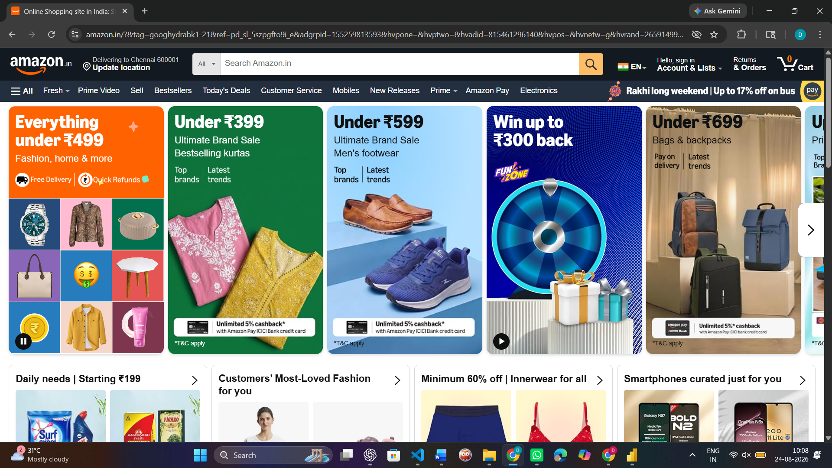

Step 1.2: Perform 5 Common Actions and Time Each One
Purpose: Generate real, observable behaviour you can analyze in later steps.
• Action 1 — Search: use the search bar to look for something relevant (a dish, a movie, a destination, a product, or a hashtag depending on your platform).
• Action 2 — Open a detail page: tap/click into one result (a restaurant page, a video page, a ride option, a product page, or a post).
• Action 3 — Commit an action: add to cart, add to watchlist, select a ride, or follow an account.
• Action 4 — Trigger a notification-worthy event: start an order, start playback, request a ride, or like a post. Stop and cancel BEFORE any real payment step.
• Action 5 — Open Settings/Profile and note what fields exist (saved address, saved payment methods, notification preferences).
• For every action, use your phone/laptop clock (or say the seconds out loud and time yourself) from the moment you tap/click to the moment the screen fully updates.

Student Note
Fill one row of the "Observed Feature" table below for each of these 5 actions as you go — do not wait until the end to write them down from memory.
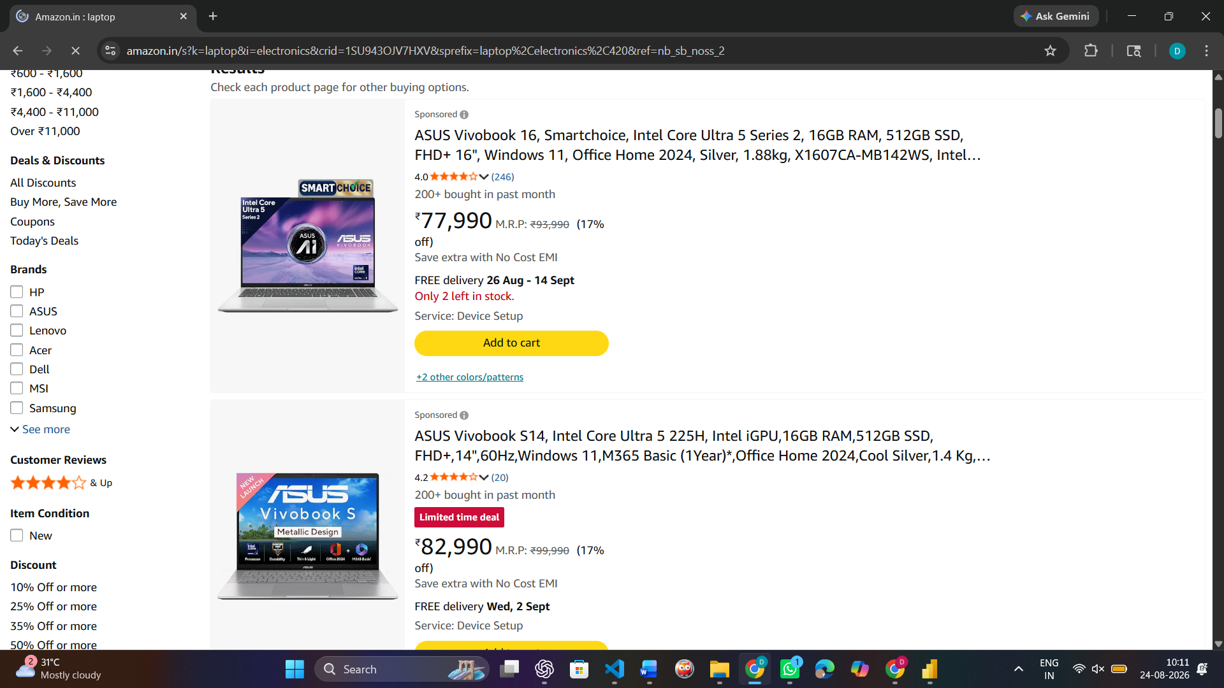

Step 1.3: Open Browser DevTools and Watch Data Requests (Website Only)
Purpose: See the platform's backend calls directly, instead of guessing.
• Right-click anywhere on the page and choose Inspect (or press F12 on Windows, or Cmd+Option+I on Mac).
• In the panel that opens, click the "Network" tab along the top.
• Click the "Fetch/XHR" filter button so only data requests show, not images or fonts.
• Tick "Preserve log" if visible, then refresh the page (F5) with the Network tab still open.
• Repeat Action 1 from Step 1.2 (search) while watching the Network panel — new rows will appear as you type or press Enter.
• Click on one new row. Read its "Name" (the endpoint being called) and its "Time" (how long it took).

Student Note
Never copy long token/key strings from the Headers tab. Only note the endpoint name pattern (for example "/api/search?q=...") and its response time in milliseconds.


Step 1.3 (App Alternative): If You Only Have a Mobile App, Use Loading-Time Evidence Instead
• Mobile apps don't show DevTools, so use what you can already see: which screens update the instant you tap something, and which show a spinner/loading animation first.
• Write in your notes: "Mobile app — network inspection not available; used on-screen loading-time evidence instead."

Step 1.4: Classify Each Feature as Real-Time or Delayed
• Go back through your 5 actions from Step 1.2, one at a time.
• Ask: did the change appear in under 1 second (Real-Time)? Did it take a few seconds but always arrive (Near-Real-Time)? Did it only appear after a refresh or a while (Delayed/Batch)?
• Write your answer for each action into the "Real-Time or Delayed" column of the table below.

Step 1.5: Search for the Platform's Official Engineering Blog
• Open a search engine and search exactly: "[platform name] engineering blog".
• Also search: "[platform name] how we built" and "[platform name] system design".
• Also check the platform's careers page (search "[platform name] careers") for a Tech Blog or Engineering link, and search YouTube for "[platform name] tech talk".
• If you find a genuine official source, write its exact title and paste the link.
• If nothing turns up after all three searches, write: "No official engineering source found after searching [search 1], [search 2], [search 3]." This is an acceptable, honest answer.

Step 1.6: Read the Privacy Policy and Permissions List
• On the app: open Settings, then look for About/Legal, then Privacy Policy.
• On the website: scroll to the very bottom of the homepage and click the "Privacy Policy" link in the footer.
• Press Ctrl+F (Windows) or Cmd+F (Mac) and type "collect" to jump straight to the data-collection section instead of reading the whole document.
• Note every data type mentioned: location, contacts, camera, device ID, payment info, browsing history, and so on.
• Also check phone-level permissions: Android — Settings > Apps > [App Name] > Permissions. iPhone — Settings > [App Name].

Student Note
Record every permission and data type you found directly in the Behavioural Evidence Log box below.

Amazon.in Privacy Notice was reviewed to understand the types of customer data collected by the platform. The privacy policy states that Amazon collects Information You Give Us, Automatic Information, and Information from Other Sources. Automatic information includes information about interaction with Amazon services and content, cookies, unique identifiers, and browser/device access information. Information from other sources may include updated delivery and address information from carriers. This shows that Amazon uses different types of customer and behavioural data to provide and improve its services.

Observed Feature | Real-Time or Delayed | What This Suggests About Processing
Amazon Home Page Loading | Near-Real-Time | Page data is fetched and displayed within a few seconds.
Laptop Search Results | Near-Real-Time | Search query is processed quickly and matching products are returned.
Product Details Page | Near-Real-Time | Product information such as price, specifications and availability is fetched quickly.
Product Recommendations | Near-Real-Time | Recommendations are generated using user activity and product data.

Behavioural Evidence Log
Type response / paste screenshot / paste diagram here.

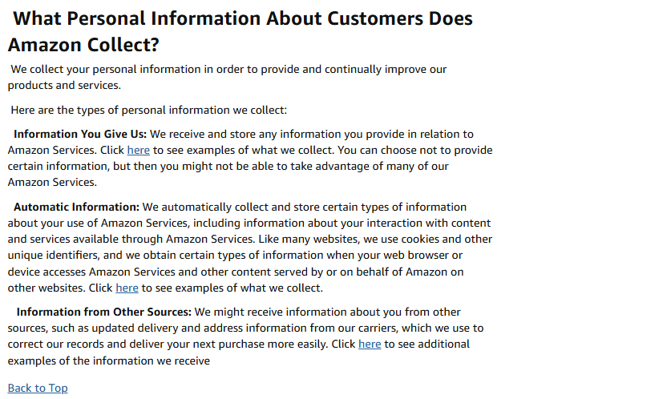

Amazon collects different types of customer information to provide and improve its services. The Privacy Notice identifies Information You Give Us, Automatic Information, and Information from Other Sources. Automatic information includes data about how customers use Amazon services, their interaction with content and services, cookies, unique identifiers, and device/browser access information. This shows that Amazon collects and processes both user-provided and automatically generated behavioural data.

Guided Tool Module 2: Infer the Likely Architecture (Cloud Architecture Centers)
Purpose: Use the same official cloud architecture references as CO4 AT2 to infer which components this platform likely uses, based on its observed behaviour and any public information about its scale.
Step 2.1: Open the Three Official Architecture Centers
• Open three new browser tabs, one for each link below.
• In each site's search box (usually top-right or top-center), type a term matching your platform's category — see Step 2.2 for exact search terms.

AWS Architecture Center: https://aws.amazon.com/architecture/
Azure Architecture Center: https://learn.microsoft.com/en-us/azure/architecture/
Google Cloud Architecture: https://docs.cloud.google.com/architecture

Step 2.2: Search Using a Term That Matches Your Platform's Category
• Food delivery / e-commerce platform: search "e-commerce reference architecture" or "retail analytics architecture".
• Streaming platform: search "media streaming architecture" or "video on demand architecture".
• Ride-hailing platform: search "real-time location architecture" or "IoT reference architecture".
• Social media platform: search "social media analytics architecture" or "real-time data architecture".
• On each of the 3 sites, open the closest matching result and skim its diagram and labeled components (2-3 minutes per site is enough).

Student Note
Record the exact page title and URL from each of the 3 sites into the table below, even if the match is only partial — use whichever result is closest.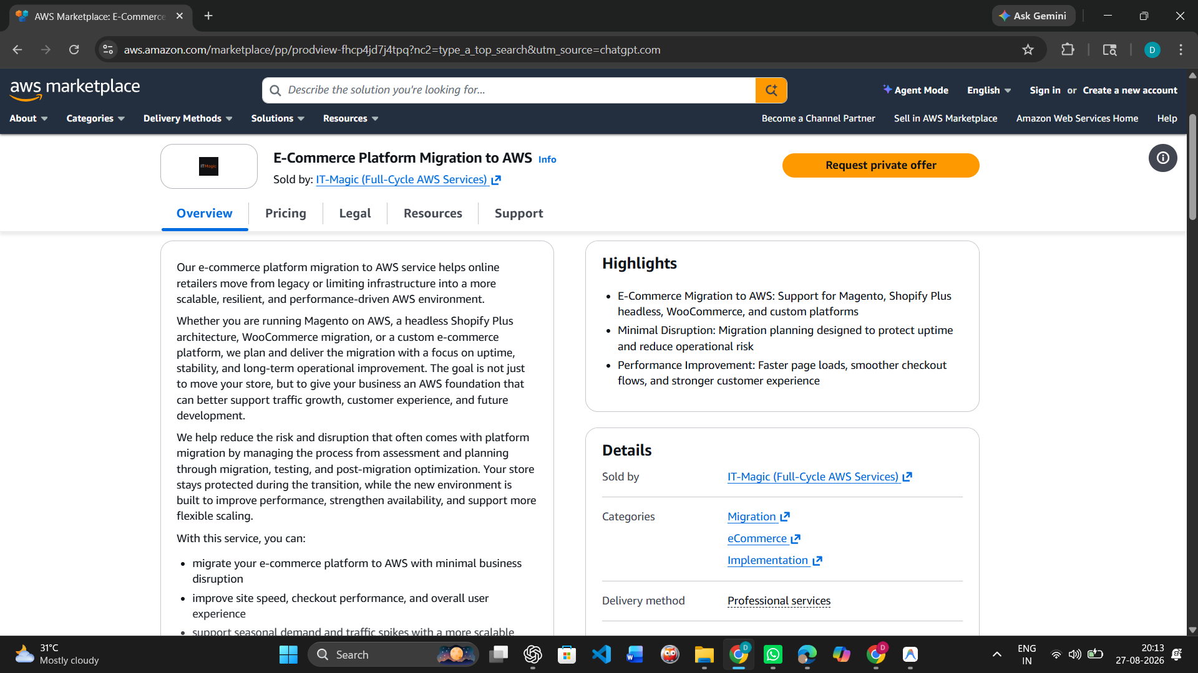
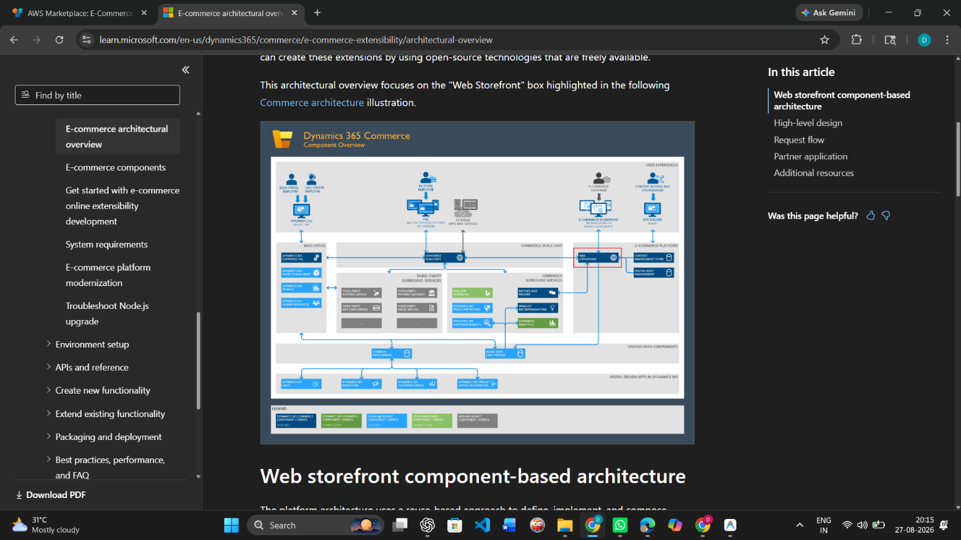
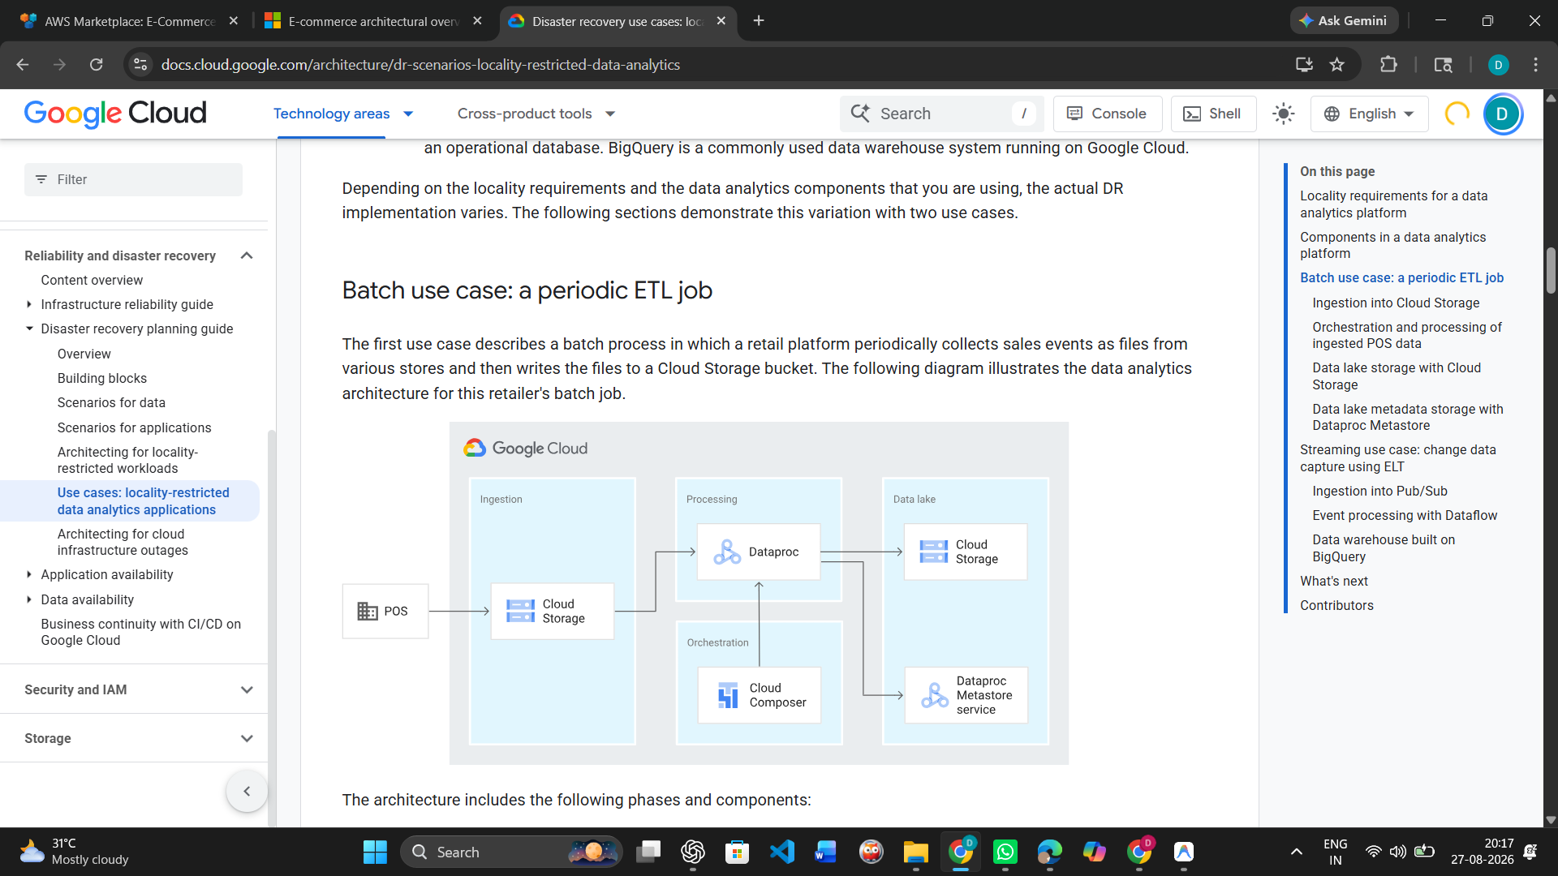

Step 2.3: Check for Public Tech-Stack Disclosure
• Open https://stackshare.io/ in a new tab. Use the search bar at the top and type your platform's exact name, then press Enter.
• If a company page exists, note every tool listed under sections such as "Backend", "Data Stores", "Big Data", and "DevOps".
• If no StackShare page exists, search instead: "[platform name] tech stack".
• Also search: "[platform name] careers backend engineer" — job postings often list required technologies (for example "experience with Kafka, Spark, AWS S3"), which is real, usable evidence.

Student Note
Record whatever you find. If nothing turns up after these three searches, write "not publicly disclosed" — that is a valid, honest finding.
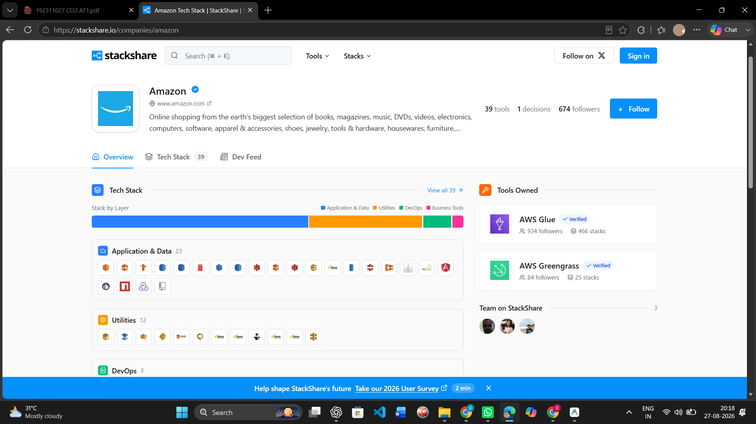

Step 2.4: Draw Your Inferred Architecture in draw.io
• Open https://app.diagrams.net in a browser. Choose "Decide Later" (no account needed) when it asks where to save.
• Create 6 boxes left to right, in this exact order: Data Sources, Ingestion, Storage, Processing, Analytics/Dashboard, Users.
• In the "Data Sources" box, write the input types you observed in Module 1 (app taps, GPS pings, sensor data, images, and so on).
• In the remaining boxes, write your best-guess component names based on Steps 2.2-2.3 (for example: "likely a streaming ingestion service, similar to Kinesis/Kafka" if your platform showed real-time behaviour).
• Draw arrows connecting the 6 boxes left to right in order.
• Export the diagram: File > Export as > PNG, and save it to your computer.

Student Note
Paste the exported PNG into the "Inferred Architecture Diagram Evidence" box further below.
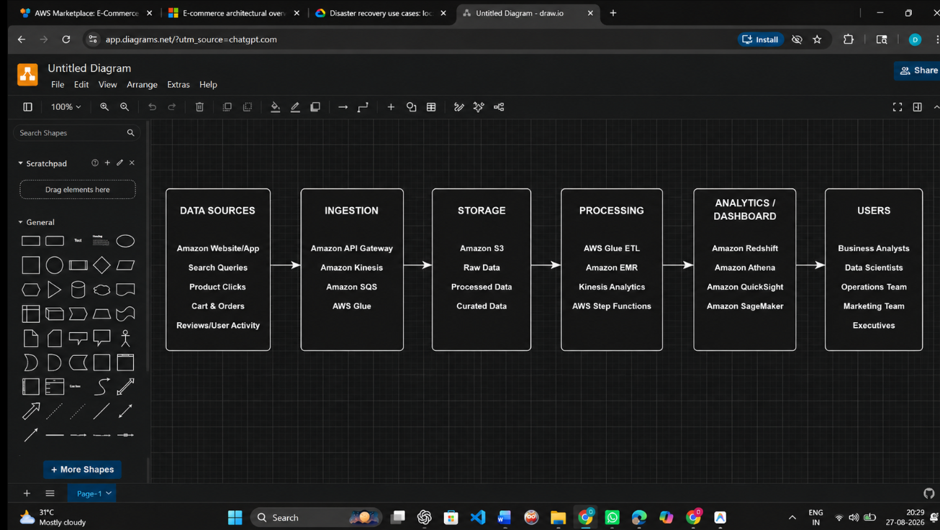

Step 2.5: Mark Confidence Levels
• Look back at your diagram's 6 boxes.
• Pick the ONE box you are most sure about (usually "Data Sources", since you observed it directly in Module 1) and write why in the table below.
• Pick the ONE box that is the biggest guess (usually the exact storage/processing technology name) and write why it is uncertain.

Inferred Component | Evidence Basis | Confidence
Data Sources | Directly observed from Amazon website/app interactions such as search queries, product clicks, cart, orders and reviews. | High
Ingestion | Inferred from AWS architecture references and the need to collect user and transaction data before storage. | Medium
Storage | Amazon S3 is inferred from AWS references and the public technology stack, but the exact internal storage implementation is not publicly confirmed. | Low
Analytics / Dashboard | Analytics components are inferred from the reference architectures and Amazon public technology stack. | Medium

Inferred Architecture Diagram Evidence
Type response / paste screenshot / paste diagram here.



Guided Tool Module 3: Infer the Processing and Analytics Approach (Hadoop/Spark Documentation)
Purpose: Decide whether the platform's observed features most likely rely on batch, streaming, or hybrid processing, using the same Hadoop/Spark documentation used in CO4 AT2.
Step 3.1: Skim the Two Official Guides
• Open the Apache Hadoop MapReduce tutorial link below and read only the "Overview" section — the first 2 paragraphs are enough.
• Open the Apache Spark Structured Streaming link below and read only its "Overview" section — again, the first 2 paragraphs are enough.
• Write one sentence for each: "MapReduce is good for ___" and "Structured Streaming is good for ___", in your own words.

Hadoop MapReduce Tutorial:
https://hadoop.apache.org/docs/stable/hadoop-mapreduce-client/hadoop-mapreduce-client-core/MapReduceTutorial.html

Spark Structured Streaming Guide:
https://spark.apache.org/docs/latest/streaming/index.html

Step 3.2: Classify Every Feature From Module 1
• Open your Step 1.2 / Step 1.4 table again.
• Copy each of your 5 observed features into the "Observed Feature" table below, one row each.
• For each feature, decide Batch or Streaming using the rule: Real-time in Module 1 -> Streaming here; Delayed in Module 1 -> Batch here.
• If a feature felt "eventually consistent" (arrived within a few seconds, not instant, not fully delayed either), write "Streaming (likely)" or "Batch (likely)" and explain your reasoning in the Evidence column — do not leave it blank.

Step 3.3: Decide the Overall Pipeline Type
• Count how many of your 5 features you classified as Streaming versus Batch in Step 3.2.
• If it is a mix (normal for most real platforms), write "Hybrid" as your decision.
• Explain in one or two sentences: which features genuinely need streaming and why, and which features are fine running as batch and why.

Step 3.4: Write a Pseudo-Flow for One Feature
• Pick your single most confident Streaming or Batch feature from Step 3.2.
• Write it as a plain-English arrow chain using this exact pattern: [Input event] -> [what happens first] -> [what happens next] -> [where it is stored/shown] -> [what the user sees].
• Keep it to 4-6 arrows. Do not write real code — this is a plain-English flow, not a program.

Example (location ping):
GPS ping from phone -> streamed to ingestion service -> matched against route ->
ETA recalculated -> pushed to rider's app screen

Observed Feature | Batch or Streaming (Inferred) | Evidence / Reasoning
Product Search Results | Streaming | Search results are displayed immediately after the user enters a query, so near-real-time processing is required.
Product Recommendations | Streaming (likely) | Recommendations change based on recent searches, clicks, and user activity, indicating near-real-time processing.
Order / Sales Analytics | Batch | Historical order and sales data can be processed periodically for reports and large-scale analysis.
Cart Updates | Streaming | Products added or removed from the cart are reflected immediately for the user.

Processing Inference
Type response / paste screenshot / paste diagram here.
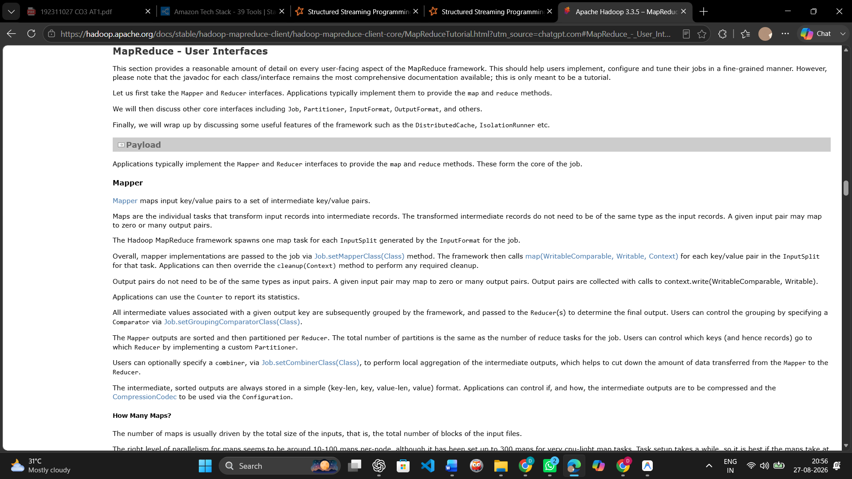
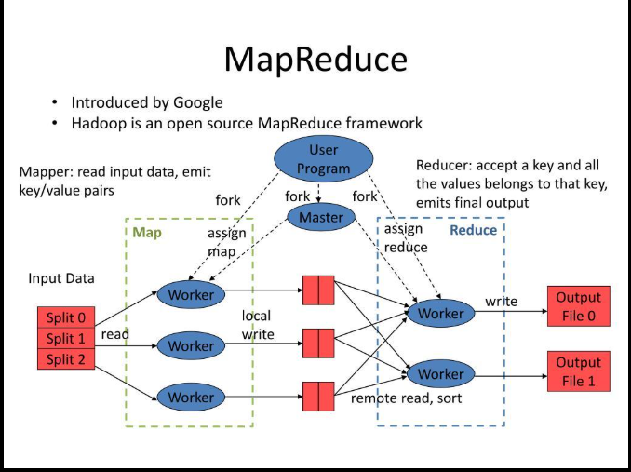

Pseudo-Flow for One Feature
Type response / paste screenshot / paste diagram here.

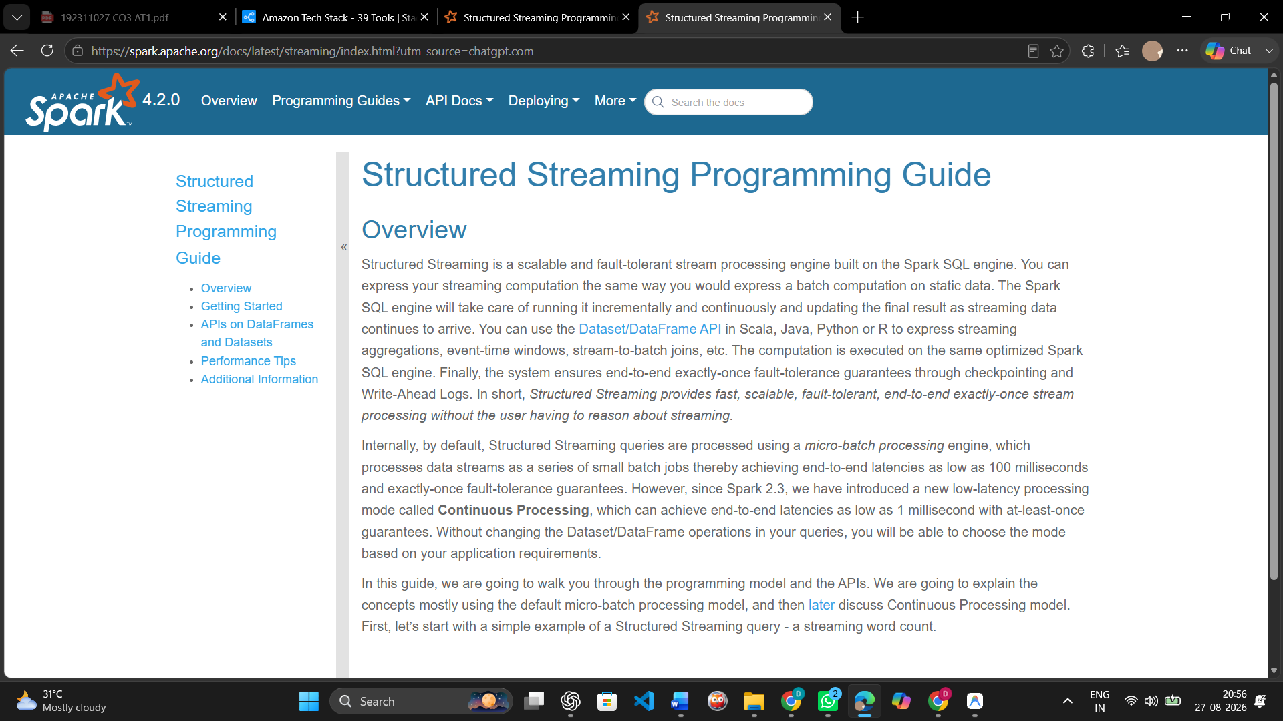
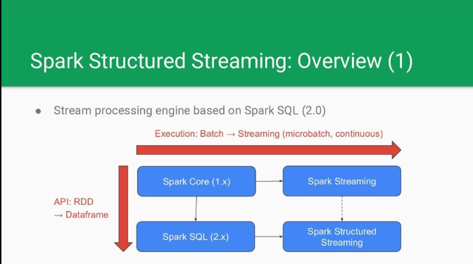

Guided Tool Module 4: Infer Privacy and Security Risks (Threat Modeling)
Tool Choice
Use OWASP Threat Dragon if you need a web/desktop cross-platform threat modeling tool. Use Microsoft Threat Modeling Tool when a Windows system is available. The required evidence is the threat model diagram and threat-control table.

Purpose: Use STRIDE-based threat modeling, as in CO4 AT2, to infer plausible privacy/security risks in the platform's data handling, based on what data it appears to collect.
Step 4.1: List Data Types With a Sensitivity Rating
• Go back to your Module 1, Step 1.6 privacy-policy findings.
• Copy each data type you found into the table below.
• Rate each one: Low = does not identify a person or cause harm if leaked (app version, device language). Medium = identifies a person but limited harm (name, email). High = could cause real harm if leaked (exact location, payment card, health data, biometrics).

Step 4.2: Open a Threat Modeling Tool and Create a New Model
• Web version (no install): go to the Threat Dragon link below and sign in with a free GitHub account if prompted, or use "Open Local Threat Model".
• Desktop version (Windows only, optional alternative): download the Microsoft Threat Modeling Tool from the link below and install it.
• Click "New Threat Model" / "Create Model".
• Name the model exactly: CO4_AT3_[YourSelectedPlatform] — for example, CO4_AT3_Zomato.

OWASP Threat Dragon:
https://owasp.org/www-project-threat-dragon/

Microsoft Threat Modeling Tool:
https://learn.microsoft.com/en-us/azure/security/develop/threat-modeling-tool-releases

Step 4.3: Build the Diagram
• From the left toolbar, drag an Actor (stick-figure icon) onto the canvas for each external entity you identified — at minimum the end user, plus one more (payment gateway, GPS provider, etc.).
• Drag a Process (circle icon) for each processing step from your Module 2 diagram (for example "Ingestion Service", "Analytics Engine").
• Drag a Data Store (parallel-lines icon) for each storage component (for example "User Database", "Event Log Storage").
• Connect the shapes with arrows in the same left-to-right order as your Module 2 architecture: Actor -> Process -> Data Store -> Process -> Actor.
• Use the toolbar's Trust Boundary line tool to mark any arrow that crosses from outside the company (the user's phone) to inside the company (the server).
• Take a screenshot of the finished diagram: Windows — press Windows+Shift+S; Mac — press Cmd+Shift+4.

Step 4.4: Generate and Answer Threats Using STRIDE
• Right-click each Process or Data Store shape and choose "Add Threat" (or open the Threats panel on the right side of the screen).
• The tool suggests STRIDE categories (Spoofing, Tampering, Repudiation, Information Disclosure, Denial of Service, Elevation of Privilege) per shape.
• For at least 3 of your components, open the suggested threats and pick ONE realistic threat per component — you do not need to answer every suggestion.
• In the Mitigation/Description box for each chosen threat, write a one-line description of the risk and its impact, then copy that same line into your workbook table below.

Step 4.5: Match Each Threat to a Real-World Control
• For each threat in your table, go back to the actual app/website and look for a visible trust signal: does it ask for a 2FA/OTP code at login? Does the address bar show a padlock/https? Does the privacy policy mention encryption?
• Write the matching control next to each threat.
• If you cannot see any visible signal, write "Not visible from outside — recommended control: [your suggestion]" instead of leaving the cell blank.

Component / Data Flow (Inferred) | Threat | Impact | Likely / Recommended Mitigation
Healthcare User → Emergency Data Collection | Spoofing | Fake user may submit false emergency data | User authentication and access control
Emergency Data Collection → Data Processing & Analytics | Tampering | Emergency data may be modified | Encryption and integrity validation
Healthcare Data Storage | Information Disclosure | Sensitive healthcare data may be exposed | Encrypt stored data and restrict access
Alert & Notification Service | Denial of Service | Emergency alerts may be delayed or unavailable | Rate limiting, monitoring and redundancy

Threat Model Diagram Evidence
Type response / paste screenshot / paste diagram here.

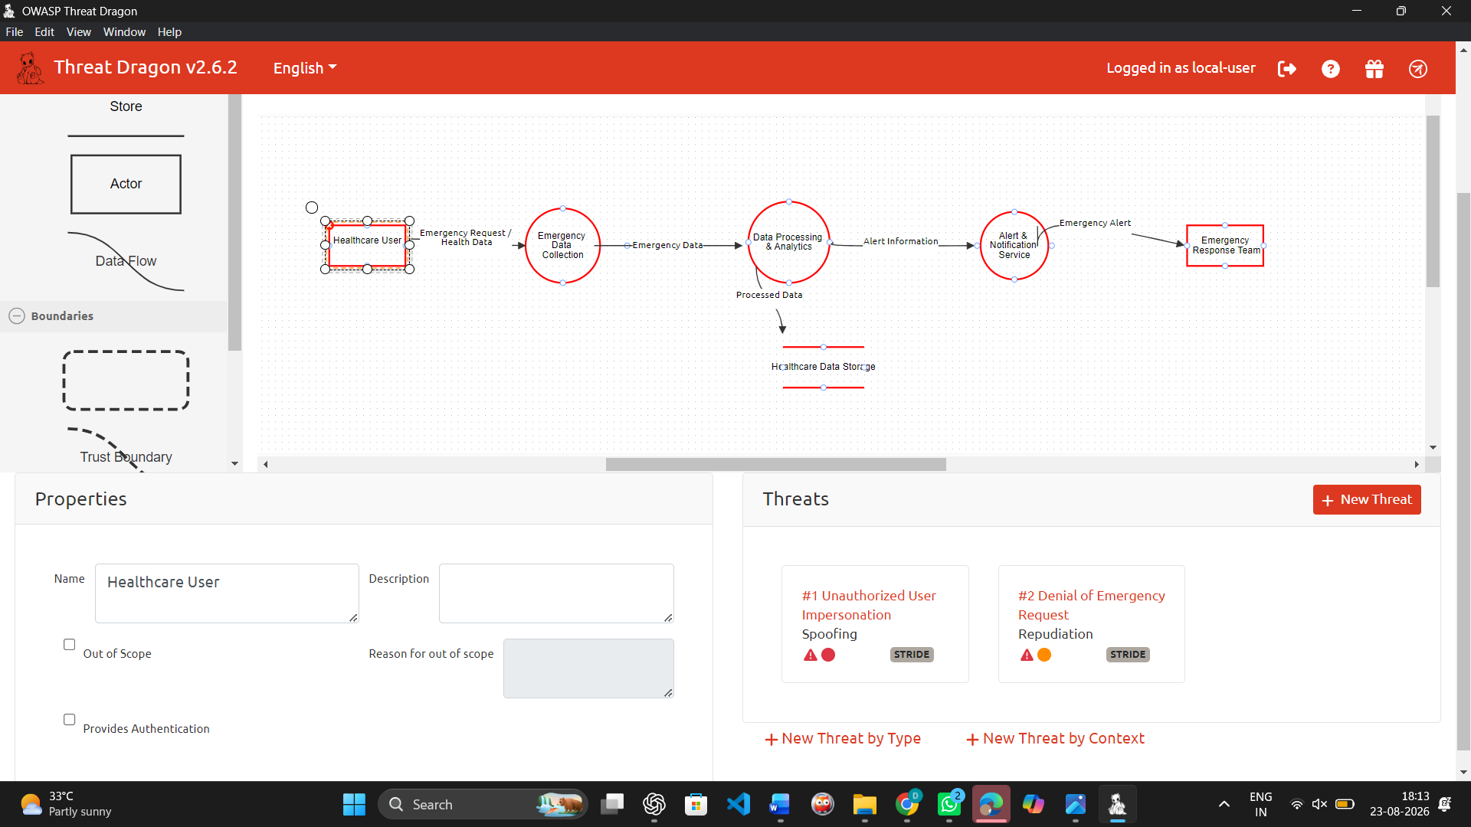

Final CO4 AT3 Solution Sections
Final Assembly
After completing the guided tool modules, combine the evidence into the final solution. The final answer must show technical reasoning and honest uncertainty, not only screenshots.

1. Platform Overview and Why It Was Selected
What to include: Identify the platform, its core users, its core function, and why it is a suitable reverse-engineering target.
Amazon E-commerce Platform was selected as the target for reverse engineering. The platform mainly serves customers, sellers, business teams and operational users. Its core functions include product search, browsing, recommendations, cart management, ordering, payments and order tracking. Amazon is a suitable reverse-engineering target because its externally observable features show continuous user interaction and significant data-driven functionality. Search queries, clicks, orders, reviews and recommendations provide useful behavioural evidence for inferring a possible data and analytics architecture

2. 5Vs Mapping (Inferred)
What to include: Map Volume, Velocity, Variety, Veracity and Value using the behavioural evidence gathered in Module 1.
The Amazon e-commerce platform is inferred to exhibit all five characteristics of Big Data. Volume is high because large amounts of product, customer, search, click, cart, order, and review data are generated. Velocity is high because searches, clicks, cart updates, and orders occur continuously and require timely processing. Variety is high because the platform handles different forms of data such as product information, transactions, search queries, reviews, and user activity. Veracity is considered medium because transaction data is generally structured, while reviews and behavioural data may contain noise or uncertainty. Value is high because this data can support recommendations, customer experience improvements, operational analytics, and business decisions.

3. Inferred Data Pipeline and Architecture
What to include: Paste the final inferred draw.io architecture showing sources, ingestion, storage, processing, analytics/security and users.
The inferred architecture follows this general flow:
Data Sources → Ingestion → Storage → Processing → Analytics/Dashboard → Users
Data sources include the Amazon website/app, search queries, product clicks, cart and order activities, and reviews/user activity. Based on the external technical evidence collected, a plausible architecture may use AWS services for ingestion, storage, processing and analytics. However, the exact internal configuration cannot be confirmed through outside observation.

4. Inferred Processing Approach
What to include: State the batch / streaming / hybrid decision from Module 3 with supporting evidence.
Type response / paste screenshot / paste diagram here.

The platform is inferred to use a hybrid processing approach, combining streaming and batch-style processing. Customer-facing activities such as searches, clicks, cart updates, orders and recommendations require low-latency processing and therefore suggest streaming or near-real-time processing. Historical sales analysis, reporting, model training and aggregated analytics are more suitable for batch processing. The exact technologies and processing intervals cannot be confirmed externally.

5. Inferred Privacy and Security Risks
What to include: Summarize the threat model output from Module 4: risks identified and their likely or recommended mitigations.
Type response / paste screenshot / paste diagram here.

The platform is inferred to use a hybrid processing approach, combining streaming and batch-style processing. Customer-facing activities such as searches, clicks, cart updates, orders and recommendations require low-latency processing and therefore suggest streaming or near-real-time processing. Historical sales analysis, reporting, model training and aggregated analytics are more suitable for batch processing. The exact technologies and processing intervals cannot be confirmed externally.

6. Confidence and Evidence Summary
What to include: List each major inference made in this workbook alongside its confidence level (High / Medium / Guess) and the evidence it is based on.
The inference that Amazon generates multiple types of user and transaction data has High confidence because search, product browsing, cart, order, and review functions can be directly observed. The need for large-scale data processing also has High confidence based on the behaviour and scale of an e-commerce platform. The use of a hybrid batch and streaming processing approach has Medium confidence, inferred from real-time customer interactions combined with historical analytics requirements. A scalable cloud-based architecture has Medium confidence based on the technical evidence collected during the investigation. However, the exact storage technologies, processing configurations, and internal security controls have Low/Guess confidence because these internal implementation details cannot be directly observed from outside the platform.

7. What Could Not Be Determined
What to include: State honestly which parts of the architecture, pipeline, or risk model could not be inferred from outside observation, and why.
Type response / paste screenshot / paste diagram here.

The exact internal architecture of Amazon could not be determined through external observation. Specific database configurations, server counts, data volumes, processing intervals, network topology, internal APIs, encryption configurations, access-control policies and exact analytics algorithms are not publicly visible from normal platform usage. Therefore, the architecture produced in this activity should be treated as an inferred model rather than a confirmed representation of Amazon's production system.

8. Business / Product Decisions the Analytics Likely Supports
What to include: State the measurable outcome the inferred analytics probably drives: faster ETA, higher conversion, personalized recommendations, fraud reduction, or similar.
Type response / paste screenshot / paste diagram here.

The inferred analytics pipeline likely supports measurable business and product outcomes such as personalized product recommendations, improved search relevance, faster customer responses, conversion improvement, demand forecasting, inventory planning, fraud-risk reduction and operational monitoring. Analysis of search, click, cart and order behaviour can also help identify customer preferences and improve the shopping experience. These outcomes are reasonable inferences from the observable functions of an e-commerce platform rather than confirmed details of Amazon's internal decision systems.

Rubric
Criteria | Marks | Evaluation Focus | Evidence
Behavioural evidence quality | 6 | Observations are specific, sourced and go beyond guessing. | Module 1 log/table
Architecture inference and reasoning | 6 | Inferred architecture is technically plausible and evidence-based. | draw.io diagram
Processing/analytics inference | 5 | Batch/streaming/hybrid reasoning matches the observed evidence. | Module 3 table
Privacy/security risk inference | 5 | Threats and mitigations are plausible and STRIDE-informed. | Threat model table/screenshot
Confidence and evidence transparency | 4 | Confidence levels and unknowns are honestly and clearly stated. | Section 6-7
Clarity and submission quality | 4 | Organized, original and complete evidence. | GitHub/GCR

Total Marks: 30

Submission Checklist
Checklist Item | Status
Student details and selected platform are filled. | Done / Pending
Behavioural observation log is completed with at least 5 observations. | Done / Pending
Inferred architecture diagram is included with confidence levels noted. | Done / Pending
Processing/analytics inference table is completed. | Done / Pending
Threat model diagram/table is included. | Done / Pending
All 8 final solution sections are completed. | Done / Pending
"What could not be determined" section is honestly completed. | Done / Pending
DOCX/PDF and supporting files are uploaded to GitHub. | Done / Pending
GitHub repository link is submitted through Google Classroom. | Done / Pending

Official Reference Links
• AWS Architecture Center: https://aws.amazon.com/architecture/
• Azure Architecture Center: https://learn.microsoft.com/en-us/azure/architecture/
• Google Cloud Architecture Center: https://docs.cloud.google.com/architecture
• Apache Hadoop MapReduce Tutorial: https://hadoop.apache.org/docs/stable/hadoop-mapreduce-client/hadoop-mapreduce-client-core/MapReduceTutorial.html
• Apache Spark Structured Streaming: https://spark.apache.org/docs/latest/streaming/index.html
• Microsoft Threat Modeling Tool releases: https://learn.microsoft.com/en-us/azure/security/develop/threat-modeling-tool-releases
• OWASP Threat Dragon: https://owasp.org/www-project-threat-dragon/
• StackShare (public company tech-stack disclosures): https://stackshare.io/

